

Cuisine 2.0

An AI-powered cuisine for smart consumption with enhanced nutrition



Team: AYB Creations

*Diploma in Information Technology*

*in*

*Big Data Analytics*

**First Review**

**Design**

**Supervisor:** Mr Zoubeir Aungnoo

**AYB Team Members:**

* BABOOLULL Yougesh
* BHAGOOLI Divesh Singh
* SUBRON Jhivesh Kumar

**Date: 07 April 2021**

# Abstract

Designing is an interesting section in the project management cycle, where developers anticipate upcoming challenges and difficulties. It is where user requirements are transformed into a functional prototype.

Our Cuisine 2.0 project has 3 main parts:

* Cuisine Vision: A screen mount using a raspberry pi.
* Cuisine Android app
* Cuisine 2.0 Website

Each part has been linked to a main server, each accessing the same Database using our custom written PHP APIs.

**Table of Contents**

Abstract 2

Our Potential Users 4

Project Models 4

Database 5

Database-Relationship Diagram 5

Description of Tables Used 5

XML Files 6

API 6

Object Detection 7

Model 7

Algorithm 7

Android App 7

UML Diagram 7

Website 7

Raspberry Pi 7

Server 7

User Interface 7

Android App 7

Raspberry Pi 8

Website 8

**Table of figures**

No table of figures entries found.

# Our Potential Users

//To be done by @Yougesh

# Project Models

## Database

Our project uses a MySQL database (u511941246_cuisineUserAcc) to store user credentials. The table has 2 tables: UserAuth, User_Secret_Keys.

### Database-Relationship Diagram

Via PHP APIs

u511941246_cuisineUserAcc

Cuisine 2.0Android App

UserAuth

User_Secret_Keys

Cuisine Vision

Cuisine 2.0 Website

## Description of Tables Used

The fields in the UserAuth table are: UserId, First Name, Last Name, Email Address, Verified.

|  |  |  |
| --- | --- | --- |
| **Field Name** | **Datatype** | **Description** |
| UserId | Integer | It is a unique id assigned to each user account created to be able to identify each user correctly. |
| First Name | String | It is the First Name of the User. |
| Last Name | String | It is the Last Name of the User. |
| Email Address | String | It is the email of the User |
| Verified | Boolean | It acts as a flag to check if a user has verified his email address or not. |

The fields in the User_Secret_Keys table are: UserId, Password.

|  |  |  |
| --- | --- | --- |
| **Field Name** | **Datatype** | **Description** |
| UserId | Integer | It is a unique id assigned to each user account created to be able to identify each user correctly. |
| Password | String (256) | It stores the password of the user which is encrypted using PHP SHA-256 cryptographic hashing method. There is no possible way of reversing a cryptographic hashed password as it uses a one-way function which makes the user account one of the most secured. |

//inventory and grocery list tables not yet added.

## API

//PHP API to be done by @Yougesh

## Object Detection

//Documentation already done and reviewed… @Divesh need to be add the part we reviewed already

### Model

//To be reviewed @Divesh

### Algorithm

//to be reviewed @Divesh

## Android App

The Android App makes use of a combination of activities and fragments to make user navigation easier.

### Project Classes UML Diagrams

* **MainActivity Activity**

This activity handles the login page of the app. It makes php requests to the Server using Google’s Volley library. Volley is a standard HTTP library that makes networking for android apps easier and faster.

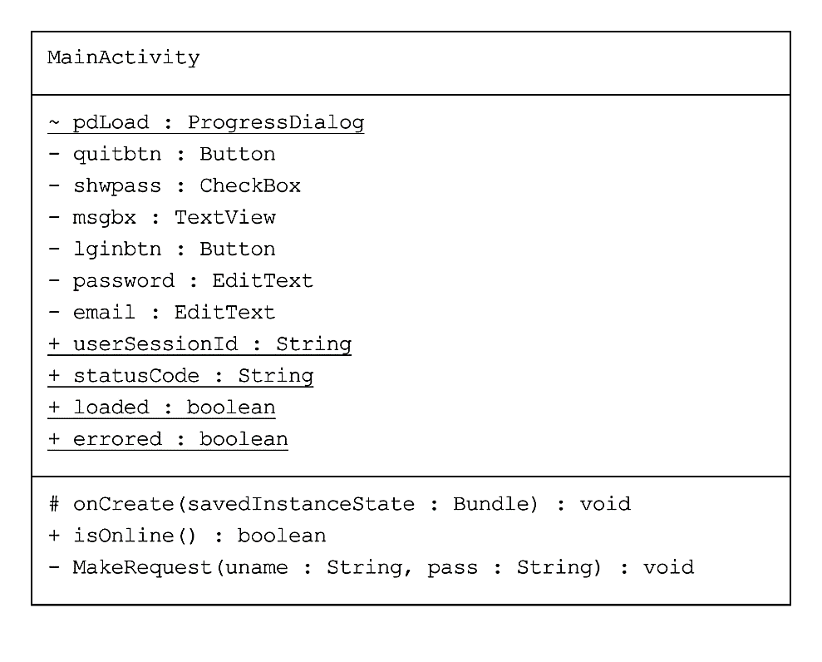

* **App_Screen Activity**

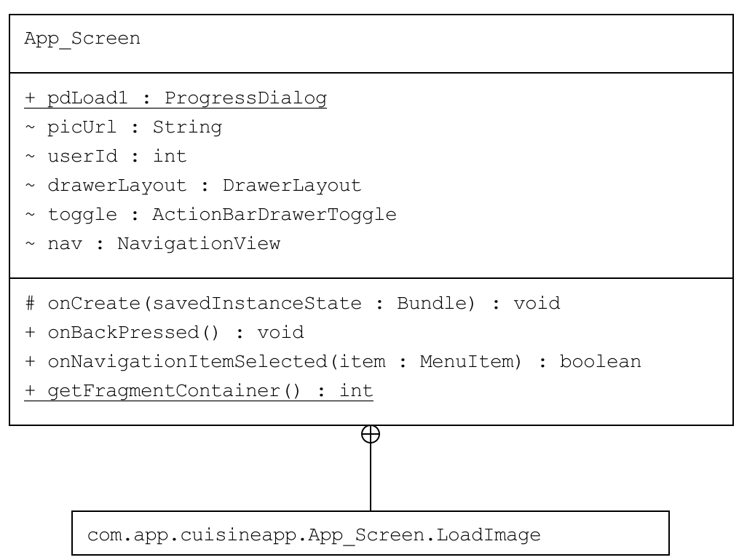This Activity extends the navigation view which is a left slider menu. It also handles the fragment views by swapping the fragment container with the selected item layout.

* **Error Page Activity**

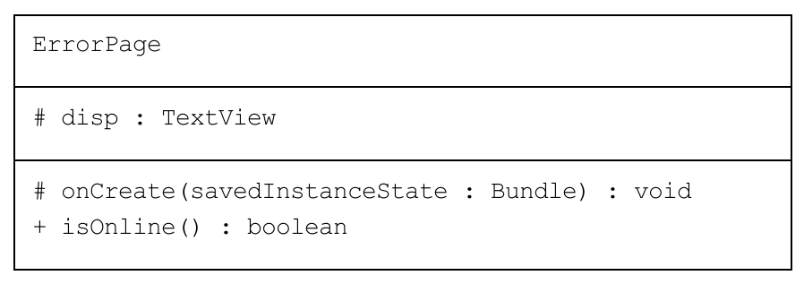This activity is shown when the app faces a network issue or loss of internet connection. It has a timer that checks for internet connection every 5 seconds. If stable internet connection is found, it redirects the user to the page he was on

## Website

The website of Cuisine 2.0 has been designed and implemented using WordPress. WordPress is a free and open-source content management system written in PHP and MySQL or MariaDB Database

//To be done by @Yougesh

## Raspberry Pi

// photos and description by @Divesh

// Circuitry by @Yougesh

# Server

//@Subron complete this part

//Review areas: Hostinger, ibm cloud

//Hostinger you already have access. IBM cloud: Communicate with @Divesh for further explanation.

# User Interface

## Android App

* 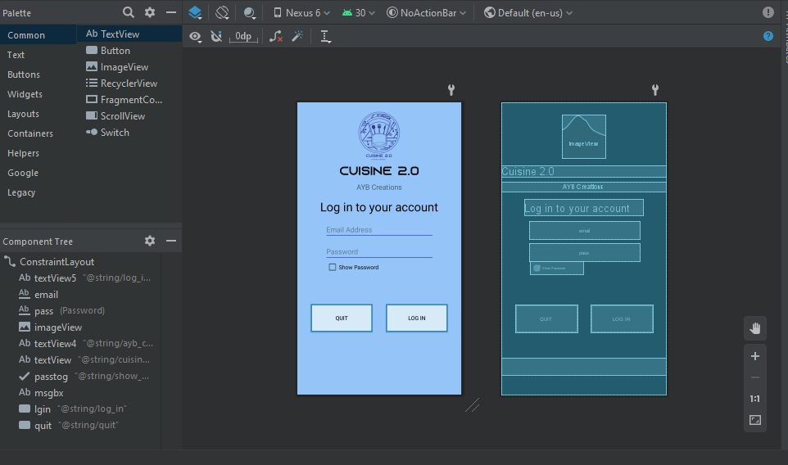MainActivity
* 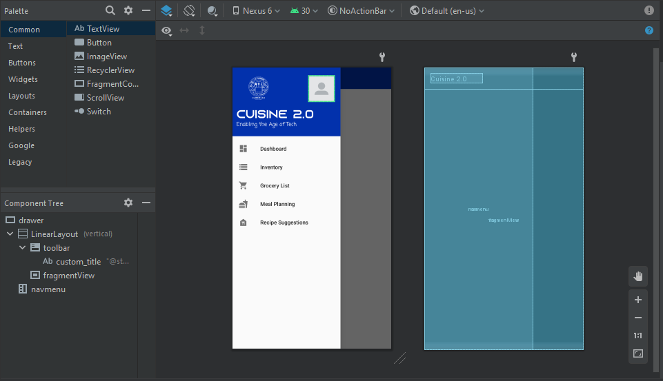App Screen – Navigation Left Slider
* Error Page

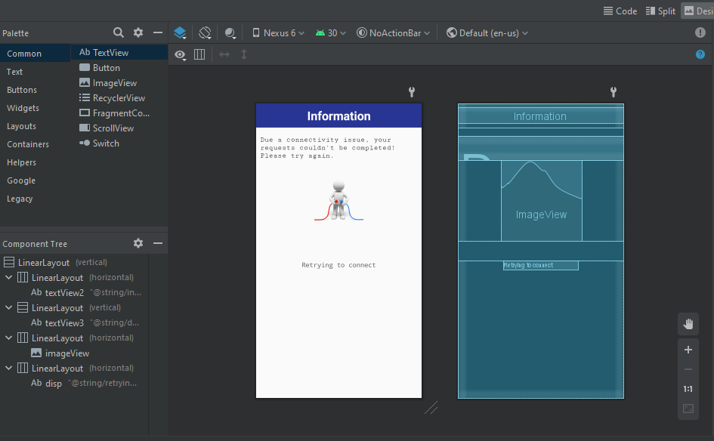

//Fragments and some more layouts to be reviewed – by @Yougesh

## Raspberry Pi

//Still under development

## Website

// @Subron Check this one too.

// Screenshot by viewing each page the dashboard.